**Applied Statistics for Finance and Economics**

**L1064**

**Project Report**

**Candidate Number: 119562**

**INTRO**

This first aim of this project, is to test using well known statistical methods, and describe the differences between the log returns of a particular stock (y), relative to it’s index, the Standard & Poor 500 index (sap). I will then be looking at…

**DESCRIPTIVE STATISTICS**

In order to present and describe the log returns so that we can better understand their properties, I have conducted the following tests and described them below. I have calculated the mean, median, standard deviation, and the specific percentiles of the data using the ‘sum’ command in Stata. These can be observed for the log returns of y (dly) in table 1 and the log returns of the S&P 500 (dlsap) in table 2. I have then graphically included a boxplot, a kernel plot, a P-P plot and a time series graph for each of the variables dly and dlsap and explained their significance.

Beginning with the log returns of the single stock, y, we can see a detailed description of some of its properties in the table below:

**TABLE 1:**

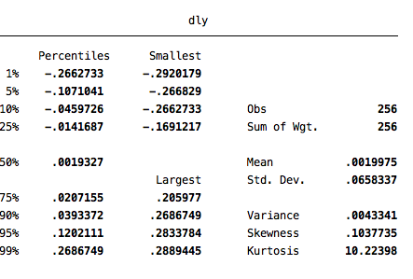

As we can see, the mean value of the log returns of y is 0.0019975, whereas the median displayed in the above graph as the 50th percentile, is 0.0019327, this points towards the fact that the data is right skewed, which is then backed up by the fact that the coefficient of skewness is positive, further outlining the fact that the data is right-skewed. The ‘peakedness’ of the data can aslo be seen to be much greater than a normal distribution of data, with a Kurtosis coefficient of 10.22398, (the normal distribution has a coefficient of 3). This is also shown graphically below.





Skewness is a measure of the lack of symmetry of a distribution. If the distribution is symmetric, the coefficient of skewness is 0. If the coefficient is negative, the median is usually greater than the mean and the distribution is said to be skewed left. If the coefficient is positive, the median is usually less than the mean and the distribution is said to be skewed right. Kurtosis (from the Greek kurtosis, meaning curvature) is a measure of peakedness of a distribution. The smaller the coefficient of kurtosis, the flatter the distribution. The normal distribution has a coefficient of kurtosis of 3 and provides a convenient benchmark.